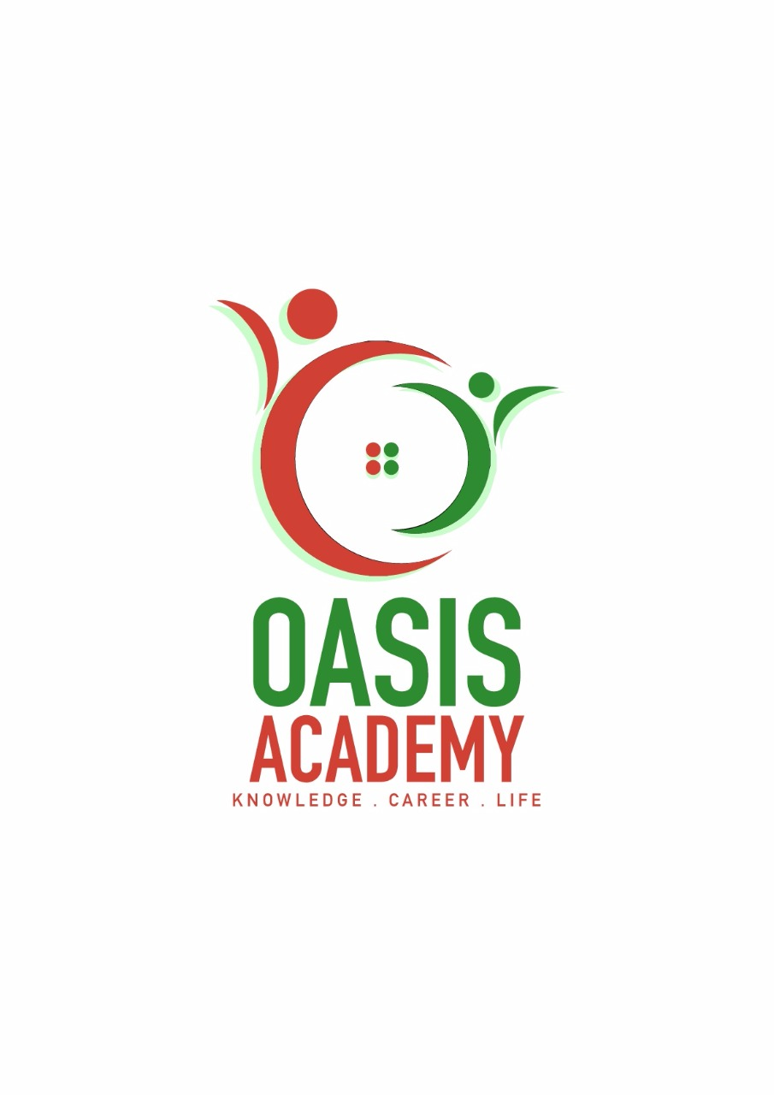
Name: Lim Ying jia
Login ID: limyingjia@oasisportal.com
Course title: Tourism and hospitality
Subject Code: BHM04

Submitted date: 11-09-2017

Table of Contents
No | Details | Page
1 | Executive Summary | 3
2 | Introduction | 4
3 | Assignment Question
 | Part 1 | 5-6
 | Part 2 | 7-9
 | Part 3 | 10-14
 | Part 4 | 15-16
4 | Conclusion | 17
5 | References | 18-19
6 | Appendix | 20

Executive Summary
In this module, I learned about accounting fundamentals. It is about the methods for recording transactions,keeping financial records, performing internal audits,reporting and analyzing financial information to the management, and advising on taxation matters. For the firstly , I learned the role of accounting. So I will defind what my understanding in the role of accounting. Secondly, I studied what is the difference between accounts payable and receivable. Furthermore , I will explain about why does a company’s profit appear as a credit on its balance sheet. So I also will defind accounting equation and trading and profit and loss account. Finally , I can explain what is the meaning of reconciliation account.

Introduction
In this assignment, I learned and understand hospitality is one of the faster growing sectors of the economy of our time today and it is a multi-billion dollar enterprise. Next , it should diverse enough people to work in different area of interest and still be employed within the industry . Hotel business are open 365 days a year and twenty four hours a day .They also provide a guest satisfaction . On the other day , in this hospitality business they should have a formal education should be obtained . I did know the service products of the hospitality business are intangible and preshable . Furthermore , its split into lodging segment such as hotels , inns , motels , pensions and resorts . Finaly the hospitality industry is the industry that is responsible for providing primary food services and accommodations in places.
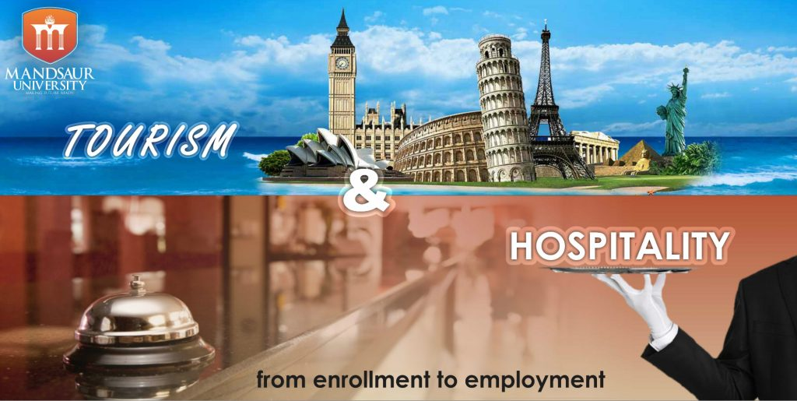

Figure 1 ( Idea of Tourism&Hospitality, 2016 )

Assignment Questions
Question 1
Define the Tourism and Hospitality
Explain your understanding about Hospitality Tourism

Answer :
-The hospitality industry is much broader than most other industries. The majority of business niches are composed of only a handful of different businesses, but this industry applies to nearly any company that is focused on customer satisfaction and meeting leisurely needs rather than basic ones. While this industry is very broad, there are some defining aspects that are important to understand.

DEFINING ASPECTS
One of the most defining aspects of this industry is that it focuses on customer satisfaction. While this is true of nearly every business, this industry relies entirely on customers’ being happy. This is because these businesses are based on providing luxury services. Very few hospitality businesses provide a basic service that people need, like food or clothing.
Another defining aspect of this industry is its reliance on disposable income and leisure time. For this reason, the majority of these businesses are for tourists or rich patrons. If disposable income decreases due to a slump or recession, then these are often the first businesses to suffer because customers won’t have the extra money to enjoy their services.

DIFFERENT BUSINESSES
Most people think that hotels alone belong to the hospitality industry, but hotels are only one sector of this industry. Many forms of transportation that cater to tourists are also part of this business world. For example, this niche includes airlines, cruise ships and even fancier trains. Restaurants, general tourism and event planning also belong to this niche.
Some of these businesses partially belong to the hospitality industry. For example, a fast food restaurant would be considered convenient. A restaurant that provides fancy food with amazing service would be providing a hospitality service.

LEVEL OF SERVICE
Regardless of the business, this industry relies heavily on providing an excellent level of service. Customers are visiting the business to get away from their troubles. A bad experience might keep them from returning ever again. Brand loyalty is very important to these customers, so the associated companies do their best to provide the best service.
Companies hire employees based on skill and behavior. Most of these employees are great with customers, and they can flawlessly give the customer what he or she needs.

THEMES
Another defining aspect of the hospitality industry is its theme. This doesn’t apply to every business in this industry, but many of them use a certain theme to attract customers. For example, a fancy restaurant might have a Mediterranean theme to attract customers who like that type of food and atmosphere.
Not only does this set the business apart from competitors, but it also allows customers to judge the business on another level. Hospitality businesses that provide an authentic theme are often appreciated more than general hospitality businesses. If the above restaurant cooks authentic Mediterranean cuisine and uses the proper decorating elements, then this will make customers happy and more willing to visit the business.
A hospitality business doesn’t need a theme, but the vast majority of them use one because customers love themed businesses.

CONCLUSION
While this is a very broad industry that can incorporate many different businesses, there are some defining elements that set it apart from similar businesses. Not only do these companies focus on service and luxury, but they also depend on disposable income and giving customers what they want. The broad-reaching hospitality industry ensures that every customer is happy because brand loyalty is essential.

Question 2
Brief on different type of Tourism categories
Define Tourism

The different types of tourists in tourism industry

Tourist can be defined as a person, who makes a tour away from home for leisure, business or other purposes for more than one day but less than a year. Based on their various needs and reasons for traveling, tourists are classified in the following categories:
Incentive tourists: Incentives tourists are those few lucky individuals, who get a holiday package as a reward from his company, for good work or achieving targets, set by the company. Incentive tourists draw inspiration from such tours to work harder, improve work relations and focus on team bonding. A salesman who is awarded with a nice holiday package for accomplishing the target sales is a perfect example of incentive tourist.
Health or medical tourist: Those who seek special medical treatment, which is only possible away from home, make trips to other places and are called Health or medical tourist. Some of these tourists avail medical assistance in other countries, for they may be expensive in their own country. Many health or medical tourists also make trips simply to stay for few days in healthier climate. Hoards of medical tourist fly to South Africa from oversee countries to undergo plastic surgery.
Business tourist: Tourist traveling with relation to business is known as business tourist. Business tourism is part of the business world. Most of the cities feature conference centers that cater to the needs of business tourists. A proper example of a business tourist is a salesman, who makes trips to different places to attend trade shows, to display and promote his own products also.

Education tourists: Tourists traveling to a particular place in another town, city or country for further study in order to improve his or her educational qualification are termed as education tourist. There are also group of people, who travel to attend workshops to upgrade skills. A clinic nurse, who makes trip to another province to attend a particular workshop, qualifying individual about infectious diseases is an example of an educational tourist.
Adventure tourists: Adventure tourists look for some unusual or bizarre experience. They seek adventurous activities that may be dangerous, such as rock climbing, river rafting, skydiving, shark cave diving and bungee jumping.
Cultural tourist: These types of tourists travel to experience the essence of assorted cultures, such as San rock art, or cultural festivals such as the National Art Festival in Grahams town, or the International Jazz Festival in Cape Town. Cultural tourists also prefer to witness the World Heritage Sites of the traveled country.
Eco-tourists: Nature loving tourists, who love to go green like traveling to Bonita Gardens in Bloemfontein South Africa or similar destinations are called eco-tourists. They travel throughout the world in search of destinations not affected by pollution or much human intervention.
Leisure tourist: These tourists want to rejuvenate and revitalize with comfort, while enjoying a break from mundane routine of life. Examples of this type of tourism are cruising while vacationing or simple relaxing on a beach.
Religious tourist: Religious tourist travel to sites of religious significance. World is dotted with a number of religious locations like Hajj in Mecca, Jerusalem in Israel, Varanasi in India, and the Vatican in Rome. During Easter, a huge conglomeration of Christian pilgrimage takes place in Zion City.
Sport and recreation tourist: These sorts of tourists either take active part in or just watch sports events. Some of such popular sport events are the Soccer World Cup, Wimbledon Tennis Championship, Comrades Marathon, and Fisher River Canoe Marathon.

Backpacking or youth tourist: This group of tourist is of young age and they travel with minimum luggage and on a limited budget. But they are very passionate and love excitements and adventures, while traveling. They generally have no specific travel schedules and tend to travel independently.
Special Interest Tourist (STI): They nurture particular passion in different things like bird watching, nature, fishing during the Sardine Run, food and wine or attending the Cape Town Book Fair.

Question 3
Describe the lodging accommodation and types of hotel accommodation.
Lodging or a holiday accommodation is a type of residential accommodation. People who travel and stay away from house for more than a day need lodging for sleep, rest, food, safety, shelter from cold temperatures or rain, storage of luggage and access to common household functions .
Lodgings may be self-catering, in which case no food is provided, but cooking facilities are available.
Lodging is done in a hotel, motel, hostel or hostal, a private home (commercial, i.e. a bed and breakfast, a guest house, a vacation rental, or non-commercially, with members of hospitality services or in the home of friends), in a tent, caravan/camper (often on a campsite).

Types of hotel accommodation

Hotel - An establishment that provides travelers with paid accommodation and other guest services. Depending on size, location, and amenities, hotels are generally rated from one-star to five stars, but letter grading (from “A” to “F”) and other rating schemes are also used to categorize hotels across the world.
Hôtel Particulier - Originating in 17th century France, the term hôtel particulier usually refers to a nobleman’s townhouse of great historical and architectural significance. Out of Paris’ 2,000 original hôtels particuliers, only 500 still stand today, and many of them have been converted into museums (Musée Eugene Delacroix, Maison de Victor Hugo), ultra-exclusive retreats (Le Pourtales), or public hotels (Hôtel de Crillon, Hôtel Particulier Montmartre).
Hostel - Ideal for budget travelers and backpackers, a hostel is an inexpensive type of accommodation, usually with shared bedrooms and communal facilities.
Motel - Originally designed for motorists, motels are roadside hotels equipped with minimal amenities and ample parking areas for motor vehicles.
Cottage - In today’s tourism sector, the term cottage is used to describe a small vacation house, typically in a rural area.
Chalet - Chalets are wooden Alpine-style buildings commonly found in and around mountain resorts.

Boutique Hotel - Often furnished in a themed, individual style, boutique hotelsare intimate in size and focus on providing guests with high-quality, personalized experiences. (See also What is a Boutique Hotel)
Mansion - Usually built for the wealthy, mansions are large, opulent houses that generally pay homage to a historic architectural style.
Lodge - Although the word ’lodge’ has many different meanings, one of them refers to a small rural house used by people on holiday or occupied seasonally by sports enthusiasts (ski lodge, hunting lodge).
Timeshare - Usually located in a sought-after destination, a timeshare is a type of vacation property with shared ownership and use rights. The term first appeared in the United Kingdom during the ‘60s and has multiple variations today, both in style and type of proprietorship. Moreover, choosing a timeshare for rent can be a smart alternative to staying in a hotel room, offering superior amenities and better value.
Riad - A traditional Moroccan house built around a central courtyard, often converted into an intimate hotel or guesthouse.
Resort - Although a resort is primarily known as a destination frequented by vacationers in search of relaxation and entertainment, the term is also used to describe a full service lodging establishment that offers extensive guest services and recreational facilities.
Igloo - A typical Eskimo house, an igloo is a dome-shaped snow structure meant to provide temporary or permanent shelter in cold climates.
Cortijo - Characteristic to Southern Spain (Andalusia, La Mancha y Extremadura), a cortijo is a type of rural property usually consisting of multiple buildings, a large patio, and cultivated lands.
Villa - Originated in Roman times, a villa is often described as a luxurious country residence.
Treehouse - Usually designed for recreational purposes, a treehouse, or tree house, is a structure built or placed among the branches of a tree.
Apartment - Also known as flat (British), an apartment is a self-contained accommodation unit housed in a building containing a number of such units.
Ice Hotel - An ice hotel is a non-permanent hotel constructed from ice and snow in areas with sub-freezing temperatures.
Camp - A collection of tents, huts, or other temporary structures used for travelers to lodge in.
Pop Up Hotel - A new breed of accommodation, pop-up hotels are temporary lodging establishments, usually set up for specific events.
Palazzo - Although often translated to palace, the word palazzo has a broader meaning in Italy. It can be anything from a block of flats to the home of a noble family to a historic hotel. From an architectural point of view, however, palazzodescribes a grand, imposing building belonging to the Renaissance style.
Palazzina - The diminutive version of a palazzo, a palazzina represents a multi-story suburban house or apartment building.
BED AND BREAKFAST - A Bed and Breakfast (B&B) is an intimate, independently run lodging establishment, where breakfast is included in the room rate.
Inn - A small establishment offering overnight accommodation, food, and drink to travelers.
Finca - A Spanish rural property, usually characterized by traditional architecture and an agricultural heritage.
Penthouse - An apartment situated on the highest floor of a building, commonly appointed with luxury amenities.
Chateau - In Bordeaux, the term chateau is synonymous with vineyard estates, but it can also be used to describe a French country house or castle.
Manor - An English manor is a large historic house or mansion with land, formerly owned by nobility.
Pension - A type of guesthouse or B&B, where in addition to lodging and breakfast, guests are also offered lunch and dinner. Pensions are usually family-run and cost less than other accommodation options.
Townhouse - A townhouse is a residential multi-level property that is usually connected to a similar unit by a common sidewall.
Yurt - Popular in Mongolia, Siberia, and Turkey, yurts are circular tents covered with felt or skins, and appointed with conical roofs.
Tent - Used outdoors, a tent is a portable shelter made of fabric and supported by a frame or poles.
Dome - A dome is a roof or building with a hemispherical form. Many of today’s sustainable hotels offer cozy accommodation in eco-friendly domes made of glass, wood, snow, or other materials.
Pod - In terms of lodging, a pod is a prefabricated stand-alone structure that provides basic accommodation.

Masseria - A masseria is a large, fortified farm typical to Southern Italy, mainly the region of Puglia. Set in working farms, most of these country houses have been transformed into rustic Bed & Breakfasts, self-catering vacation rentals, and even luxurious hotels. Due to the large number of masserie, the coastal area between Bari and Brindisi is sometimes referred to as the “Masseria coast”.
Pousada - Pousada is the Portuguese term for guesthouse, inn, or historic independently-owned hotel. They usually have a traditional restaurant and offer guests an authentic local experience.
Relais - A relais is the French version of a roadside lodge or resting place.
RV - Usually used for traveling, an RV is a recreational vehicle outfitted with the amenities found in a home, including bathroom, kitchen, and sleeping facilities. Depending on region, RVs are also called caravans, camper vans, or motorhomes.
Castle - A fortified building or group of buildings built across Europe and the Middle East during the medieval period. Castle hotels offer royal-style accommodation in sumptuous historic surroundings.
Palace - Unlike castles, palaces are not fortified, but they still are royal residences characterized by an exceptional level of grandeur. Some of the most spectacular palaces converted into luxurious hotels can be found throughout Asia and Europe, especially India and Italy.
Tented Safari Camp - A tented safari camp is a permanent campsite of large accommodation units, usually with canvas walls, solid high-quality furnishings, en-suite bathroom facilities, and private decks for observing wildlife. Situated throughout Africa, they range from comfortable to ultra-luxury and offer a wide range of safari based activities.
Yacht - A type of luxury recreational boat offering every modern convenience. They are classified as sailing yachts and motor yachts, and are available in a vast range of sizes, styles, and functions.
Farmhouse - Although their styles vary by region, farmhouses are houses attached to a farm, often characterized by vernacular architecture.
Extended Stay Hotel - Extremely popular throughout the US, extended stay hotels offer the comforts of a traditional home along with discounted rates for guests interested in long-term stays.
Private Island Resort - Ideal for honeymooners and travelers in search of luxury and seclusion, private island resorts are some of the most exclusive accommodation types out there.
Cave Hotel - Cave hotels are exactly what the name implies – hotels built into natural cave formations, commonly with underground rooms. Many cave hotels can be found in Turkey (Cappadocia) and Greece.
Guesthouse - A guest house or guesthouse is a private house offering inexpensive accommodation to tourists.
Poshtel - A new trend in travel, poshtels are a sort of upscale hostels with a focus on chic design, art, and high-tech amenities.
Business Hotel - Catered primarily toBUSINESS TRAVELERS, business hotels are strategically located (downtown, in business districts, or close to major business centers) and come equipped with corporate facilities such as meeting and conference rooms, Internet access, and catering options.
Design Hotel - ADESIGN HOTEL is a stylish and intimate hotel with an emphasis on design, service, and luxury facilities. Their rooms are exquisitely decorated and often packed with the latest technology features.
Hacienda - The term hacienda is used to describe a ranch or a main house in a landed estate in Spanish speaking-countries.
Eco Hotel - An eco hotel is an environmentally friendly accommodation aiming to promote sustainable tourism and green living through the use of renewable energy sources, recycled materials, and organic locally-sourced produce. Their philosophy is to minimize the impact on the environment.
Capsule Hotel - A big hit in Japan, the capsule hotel is a unique type of hotel that usually provides cheap, basic overnight accommodation in a number of teeny-tiny functional rooms called “capsules”.
Aparthotel - A smart choice for long-term accommodation, aparthotels or apartment hotels combine the comfort and independence of a private apartment with the services of a hotel.
Parador - Paradors are Spanish government-operated hotels, frequently located in former castles, monasteries, or other beautiful historic settings.
Masia - A masia is a traditional Catalan country house.

Question 4
Explain the signficant of entertainment in this industry.
Entertainment is a form of activity that holds the attention and interest of an audience, or gives pleasure and delight.
It can be an idea or a task, but is more likely to be one of the activities or events that have developed over thousands of years specifically for the purpose of keeping an audience's attention.
Although people's attention is held by different things, because individuals have different preferences in entertainment, most forms are recognisable and familiar.
Storytelling, music, drama, dance, and different kinds of performance exist in all cultures, were supported in royal courts, developed into sophisticated forms and over time became available to all citizens.
The process has been accelerated in modern times by an entertainment industry which records and sells entertainment products.
Entertainment evolves and can be adapted to suit any scale, ranging from an individual who chooses a private entertainment from a now enormous array of pre-recorded products; to a banquet adapted for two; to any size or type of party, with appropriate music and dance; to performances intended for thousands; and even for a global audience.
The experience of being entertained has come to be strongly associated with amusement, so that one common understanding of the idea is fun and laughter, although many entertainments have a serious purpose.
This may be the case in the various forms of ceremony, celebration, religious festival, or satire for example.
Hence, there is the possibility that what appears as entertainment may also be a means of achieving insight or intellectual growth.
An important aspect of entertainment is the audience, which turns a private recreation or leisure activity into entertainment.
The audience may have a passive role, as in the case of persons watching a play, opera, television show, or film; or the audience role may be active, as in the case of games, where the participant/audience roles may be routinely reversed.
Entertainment can be public or private, involving formal, scripted performance, as in the case of theatre or concerts; or unscripted and spontaneous, as in the case of children's games.

Most forms of entertainment have persisted over many centuries, evolving due to changes in culture, technology, and fashion.
Films and video games, for example, although they use newer media, continue to tell stories, present drama, and play music.
Festivals devoted to music, film, or dance allow audiences to be entertained over a number of consecutive days.
Some activities that once were considered entertaining, particularly public punishments, have been removed from the public arena.
Others, such as fencing or archery, once necessary skills for some, have become serious sports and even professions for the participants, at the same time developing into entertainment with wider appeal for bigger audiences.
In the same way, other necessary skills, such as cooking, have developed into performances among professionals, staged as global competitions and then broadcast for entertainment.
What is entertainment for one group or individual may be regarded as work by another.
The familiar forms of entertainment have the capacity to cross over different media and have demonstrated a seemingly unlimited potential for creative remix.
This has ensured the continuity and longevity of many themes, images, and structures.

Conclusion
I have learned and done with hospitality industry is becoming one of the most demandable industries in the world day by day where as restaurant business is business is playing a vital role for flourishing the business more. It is introducing new and different food services for the customers to attract them. On the other hand ,it is a service based industry the executives should always conscious about level of service quality to ensure more customer satisfaction because the profit ability of these types of industries mainly depends on it. The restaurants also should conscious bout the price of the product while launching a new product as people are more conscious about the price in the modern era.

References
(Information from another source must be credited in the reference page)
1. Beyond( 2014 ) ( online ) SINGAPORE category education.
Retrived From :https://www.beyond.com/tourism/defined

2. Careerigniter( 2016 ) ( online ) SINGAPORE category education.
Retrived From :
http://www.careerigniter.com/questions/what-are-the-different-types-of-tourism/

3. A( 2015 ) ( online )
Retrieved From : http://www.luxuryaccommodationsblog.com/post/114961446726/different-types-accommodation-tourism

4. Business Essays ( 2011 ) ( online )
Retrieved From :
https://businessays.net/entertainment-in-the-hotel-industry/

5. Boomer and senior travel( 2012 ) ( online )
Retrieved From :
http://www.boomerandseniortravel.tv/2012/03/06/what-are-the-different-types-of-accommodations/

6. ThefreedirectionbyFarlex( 2013 ) ( online )
Retrieved From :
http://www.thefreedictionary.com/entertainment+industry

- Economywatch( 2016 ) ( online )
Retrieved From :
http://www.economywatch.com/world-industries/hospitality

Appendix
(Appendix is for more detailed information on a subject that is too long to explain in 1 page)

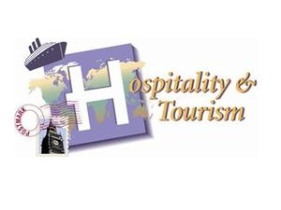
( Figure 2 ) ( Tourism&Hospitality, 2015 )

